For Loop Worksheet 1

For exercises 1 to 4, indicate the output that will be produced. Write your answers to the right of the questions.

1)

for(int j=3; j <=7; j++)

System.out.println(j);

3

4

5

6

7

2)

for(int value=8; value>4; value--)

System.out.print(value+”,”);

8,7,6,5,

3)

for(int i=1; i >= 20; i+=4)

System.out.print(i);

No output.

4)

int MAX = 20;

int num = 10;

for (int value=MAX; value >= num; value-=3)

System.out.println(value);

20

17

14

11

5)

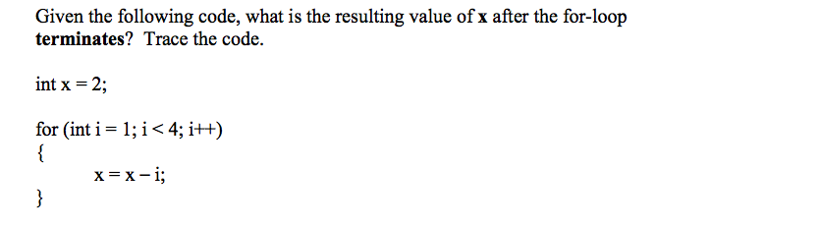

x=-4

6)

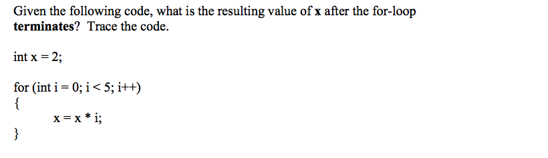

x=0

7)

7) Analyze this code. What is the value of sum after the for loop?

a)

for(int i=1;i<100;i+=2){

int sum=0;

sum+=i;

}

sum doesn’t exist outside loop, but has the value 99 at the last iteration of for

b)

int sum;

for(int i=1;i<100;i+=2){

sum+=i;

}

error compiler

8) What is the output of the following program?

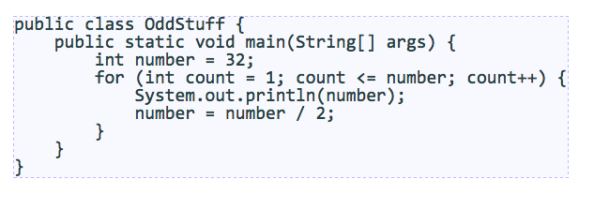

32

16

8

4